
Project Proposal

<Your Name Here>

Data Labeling Approach

Project Overview and Goal  What is the industry problem you are trying to solve? Why use ML in solving this task? | <your answer text here>

Choice of Data Labels

What labels did you decide to add to your data? And why did you decide on these labels vs any other option?

Test Questions & Quality Assurance

Number of Test Questions

Considering the size of this dataset, how many test questions did you develop to prepare for launching a data annotation job?
Improving a Test Question  Given the following test question which almost 100% of annotators missed, statistics, what steps might you take to improve or redesign this question? | 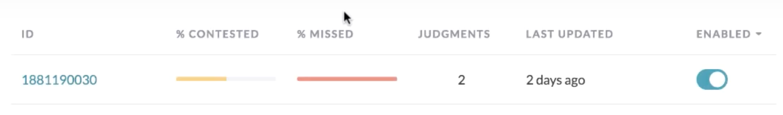  <your text here>
Contributor Satisfaction  Say you’ve run a test launch and gotten back results from your annotators; the instructions and test questions are rated below 3.5, what areas of your Instruction document would you try to improve (Examples, Test Questions, etc.) | 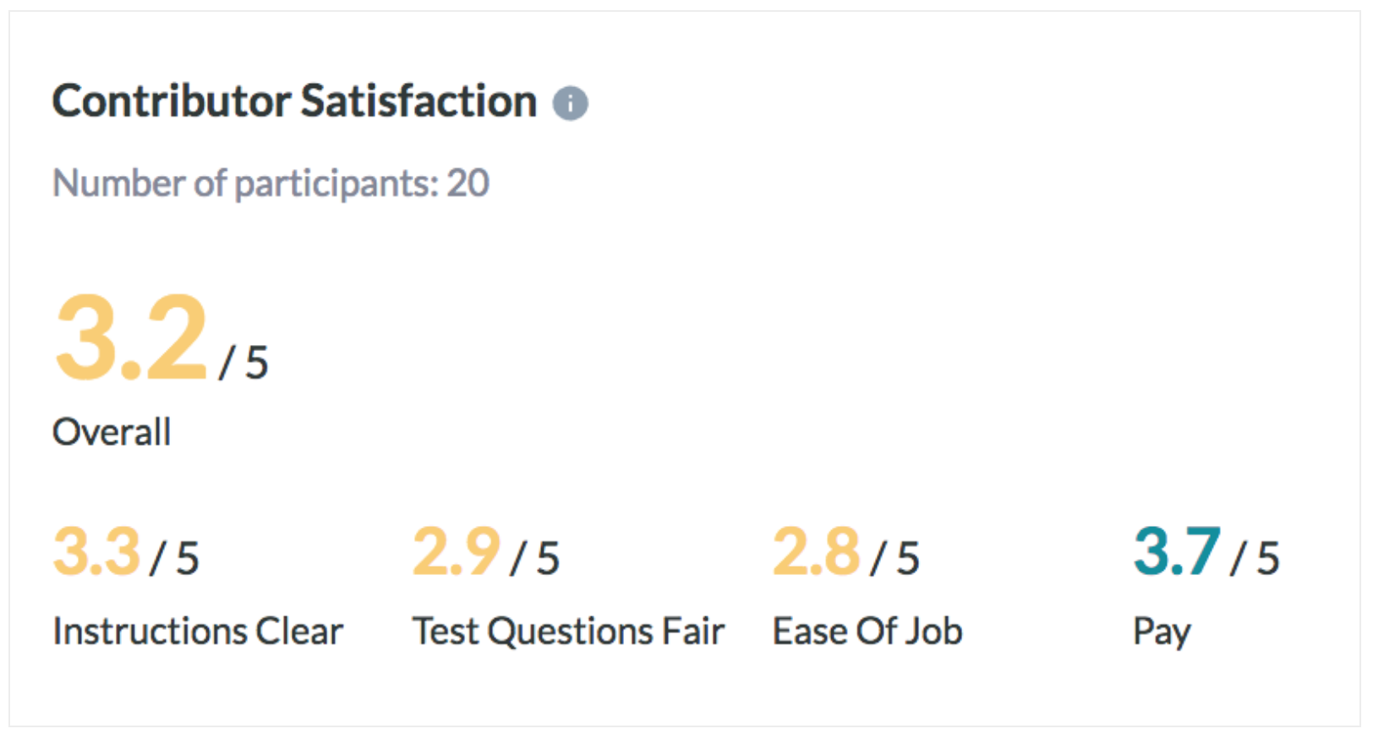  <your text here>

Limitations & Improvements

Data Source

Consider the size and source of your data; what biases are built into the data and how might the data be improved?

Designing for Longevity

How might you improve your data labeling job, test questions, or product in the long-term?

